KNOWLEDGE ENGINEERING AND ONTOLOGIES COURSE PROJECT REPORT
Ege Karataş-220316064
Murad Maharramlı-220316075
Saliha Sümeyye Cömert- 220316006

Executive Summary

This project aims to develop a comprehensive Movie Knowledge Graph and an ontology-based Question Answering (Chatbot) system, focusing on mainstream cinema data from the year 2000 to the present. Following the METHONTOLOGY framework, an OWL ontology was designed using Protégé to model the complex relationships between movies, directors, actors, and genres, integrated with external vocabularies such as Schema.org and DBpedia for enhanced interoperability. The data was sourced from a static IMDb dataset on Kaggle, preprocessed and cleaned using Python (Pandas), and subsequently transformed into RDF triples via the RDFlib library. This knowledge graph was deployed on GraphDB, enabling advanced reasoning and semantic retrieval through complex SPARQL queries. Furthermore, to address the integration of Knowledge Graphs with Large Language Models (LLMs), a specialized "Keyword" hierarchy was introduced to facilitate Natural Language Processing (NLP) tasks and ensure fact-grounded responses. The consistency and integrity of the graph were validated using SHACL shapes, resulting in a reliable and scalable semantic search infrastructure that minimizes hallucination risks in AI-driven movie recommendations and information retrieval.

Description of the project
The objective of this project is to bridge the gap between structured cinematic data and natural language processing by constructing a semantic Movie Knowledge Graph (MKG). While traditional databases allow for simple keyword searches, they often fail to capture the complex, multi-layered relationships inherent in the film industry, such as multi-actor collaborations, director-genre associations over time, and the nuanced metadata of mainstream cinema.
This project focuses on movies released from the year 2000 to the present, utilizing a curated dataset from IMDb. The primary goal is twofold:
- Semantic Modeling: To develop a robust OWL (Web Ontology Language) schema that defines entities like Movie, Actor, Director, and Genre, along with their interdependencies using a TBox/ABox framework. This ensures that the data is not just stored but "understood" by the system through logical inference.
- Intelligent Interaction: To implement an ontology-driven Question Answering (Chatbot) system. By integrating the Knowledge Graph with Large Language Models (LLMs) and utilizing SPARQL as a query bridge, the project aims to provide users with accurate, fact-grounded responses that mitigate the common "hallucination" issues found in standard generative AI.
Technically, the project leverages Protégé for ontology engineering, RDFlib for data transformation into triples, and GraphDB for hosting the triple store and executing complex semantic queries. The final output is an intelligent search engine capable of answering intricate competency questions—such as identifying specific actor pairings or analyzing a director's success within a particular genre—thereby providing a sophisticated tool for both cinema enthusiasts and researchers.

Ontology Design
This section presents the conceptual modeling of the Movie Knowledge Graph domain. The ontology was developed following the METHONTOLOGY methodology, utilizing a structured approach to define the conceptual schema and populate it with instance-level data.The design clearly distinguishes between the TBox (terminological box, representing classes and properties) and the ABox (assertional box, representing the instances).
TBox (Conceptual Schema)
The TBox defines the core structure of the domain through the following elements:
- Classes: The primary classes extending from owl:Thing are Movie, Person, and Genre. To represent professional roles, Director and Actor were modeled as specific subclasses of Person.Furthermore, as part of the Phase 2 research integration, Keyword and KeywordByClass classes were introduced to support natural language processing (NLP) and enhance the search capabilities of the ontology-based chatbot.
- Object Properties: These properties define the semantic relationships between classes. The core relationships include directedBy (linking Movie to Director), actedIn (linking Movie to Actor), and hasGenre (linking Movie to Genre).Additionally, the hasKeyword object property was established to connect domain entities to their respective search keywords.
- Data Properties: These properties assign literal values to instances. Key data properties include hasTitle (String), hasScore (Float for IMDb ratings), releaseYear (Integer), and keywordName (String).
ABox (Instance-Level Data) The ABox contains the actual data populated from the preprocessed IMDb dataset. For example, "Interstellar" and "Inception" are instances of the Movie class, "Christopher_Nolan" is an instance of the Director class, "Anne_Hathaway" is an instance of the Actor class, and "Sci-Fi" is an instance of the Genre class.
Modeling Decisions and Justifications
Several critical ontological modeling decisions were made during the design phase:
- Roles vs. Types: Instead of treating actors and directors merely as string data properties of a movie, they were explicitly modeled as subclasses of Person linked via object properties (actedIn, directedBy). This decision is crucial for enabling complex SPARQL reasoning, allowing the system to easily query collaborations between specific actors or identify individuals who serve as both actors and directors.
- External Ontology Integration: To adhere to Semantic Web best practices and ensure interoperability, core concepts were mapped to established external vocabularies, specifically utilizing elements from Schema.org (e.g., schema:Movie, schema:Person) and DBpedia.
- Extension for QA Systems: The introduction of the Keyword hierarchy was a deliberate design trade-off. While standard ontologies rely strictly on exact URI matches, adding keyword representations allows the system to bridge the gap between natural language user queries and formal SPARQL execution, directly supporting the project's goal of building an effective educational chatbot.

Data Acquisiton
The primary data source used to populate the Movie Knowledge Graph is a publicly available IMDb Movies Dataset obtained from Kaggle in CSV format. This dataset contains comprehensive metadata for mainstream movies, which perfectly aligns with the required ontology classes such as movies, directors, actors, genres, and ratings.
Data Collection Methodology Instead of relying on dynamic web scraping or external APIs, the dataset was acquired statically by downloading the CSV file directly to the local development environment. This methodology was chosen to ensure data stability, avoid potential rate-limiting or connectivity issues from APIs, and provide complete control over the dataset during the offline processing and RDF transformation stages.
Data Preprocessing Steps Data preprocessing was conducted using the Python programming language, specifically utilizing the pandas library for efficient dataframe manipulation. The raw dataset contained various columns, but only those relevant to the ontology (e.g., Series_Title, Released_Year, Genre, IMDB_Rating, Director, and Star1 through Star4) were retained. The following preprocessing steps were applied:
- Scope Filtering: To align with the project's temporal scope, the dataset was filtered to strictly include movies released from the year 2000 onwards.
- Data Aggregation: The dataset originally separated actors into four distinct columns (Star1, Star2, Star3, Star4). To simplify the subsequent RDF conversion process, these columns were concatenated into a single, comma-separated Actors column.
- Data Cleaning: Any rows containing missing values (Null/NaN) in the critical columns were completely dropped from the dataset. This step was crucial to ensure data integrity and prevent logical errors during the creation of the knowledge graph and SPARQL querying.
- Formatting: Text data was stripped of trailing spaces, and column names were standardized (e.g., IMDB_Rating to Score) to closely mirror the ontology's naming conventions.
Mapping of Data to Ontology Concepts The cleaned tabular data was programmatically mapped to the defined OWL ontology classes and properties using the rdflib Python library to generate RDF triples. The mapping rules were established as follows:
- Title was mapped to the hasTitle data property of the Movie class.
- Year was mapped to the Release Year (or releaseYear) data property.
- Score was mapped to the hasScore data property.
- Genre values were split by commas, instantiated as individuals of the Genre class, and linked to the movie via the hasGenre object property.
- Director values were instantiated as individuals of the Director class and linked via the directedBy object property.
- Actors values were split by commas, instantiated as individuals of the Person (or Actor) class, and linked to the movie via the actedIn object property.

Knowledge Graph Construction
This section details the transformation of the preprocessed tabular movie data into a fully functional semantic knowledge graph by combining it with the designed OWL ontology.
The RDF Model and Triple Structure The knowledge graph is built upon the Resource Description Framework (RDF), which is the standard model for data interchange on the Semantic Web. In RDF, knowledge is represented as a directed, labeled graph where data points are expressed as triples. Each triple consists of three core components:
- Subject: The main resource being described (represented by a unique URI, e.g., a specific movie).
- Predicate (Property): The specific relationship or attribute defining the subject (represented by a URI, e.g., directedBy or hasScore).
- Object: The value of the attribute or the related resource (can be another URI linking to an entity, or a Literal value like a string or an integer).

Using the Python rdflib library, the cleaned IMDb dataset was systematically iterated over to generate these triples. Subjects and objects were encoded as URIs using a safe string formatting approach (e.g., replacing spaces with underscores and appending release years to ensure uniqueness), while numerical values and text were stored as XML Schema Datatype (XSD) literals.
Representative Examples of RDF Triples
Below are representative examples of RDF triples derived directly from our dataset, formatted in Turtle (.ttl) syntax. These triples demonstrate how a movie instance is semantically connected to its metadata, director, and actors:
@prefix ex: <http://www.semanticweb.org/movie-ontology#> .
@prefix rdf: <http://www.w3.org/1999/02/22-rdf-syntax-ns#> .
@prefix xsd: <http://www.w3.org/2001/XMLSchema#> .

# Defining the Movie Instance (Subject)
ex:Movie_Inception_2010 rdf:type ex:Movie .

# Data Properties (Literals as Objects)
ex:Movie_Inception_2010 ex:hasTitle "Inception"^^xsd:string .
ex:Movie_Inception_2010 ex:releaseYear "2010"^^xsd:integer .
ex:Movie_Inception_2010 ex:hasScore "8.8"^^xsd:float .

# Object Properties (URIs as Objects defining relationships)
ex:Movie_Inception_2010 ex:hasGenre ex:Genre_Sci-Fi .
ex:Movie_Inception_2010 ex:directedBy ex:Director_Christopher_Nolan .
ex:Movie_Inception_2010 ex:actedIn ex:Actor_Leonardo_DiCaprio .
# Defining the related Individuals
ex:Director_Christopher_Nolan rdf:type ex:Director .
ex:Actor_Leonardo_DiCaprio rdf:type ex:Actor .
Deployment in GraphDB and Configuration
Once the RDF triples were generated via the Python script, the entire graph was serialized and saved as a Turtle (movie_knowledge_graph.ttl) file. To deploy, store, and query the knowledge graph, Ontotext GraphDB Free was utilized.
The deployment followed these specific configuration steps:
- Repository Configuration: A new repository (e.g., MovieKG) was created within GraphDB. The ruleset was configured to RDFS-Plus (Optimized). This configuration was strategically selected to enable semantic reasoning, allowing the system to automatically infer implicit knowledge from the TBox (e.g., inferring that instances of Director are also instances of Person).
- Namespace Definition: A custom namespace (http://www.semanticweb.org/movie-ontology#) was bound to the prefix ex: within the GraphDB interface to ensure all entities were uniquely identifiable, structurally organized, and easily queryable.
- Dataset Loading: The movie_knowledge_graph.ttl file was uploaded using GraphDB’s native Import > RDF interface. The parser successfully loaded the triples into the default graph. Additionally, a separate shapes.ttl file was loaded into a specific Named Graph (http://rdf4j.org/schema/rdf4j#SHACLShapeGraph) to enforce SHACL validation constraints.

Visual Representation
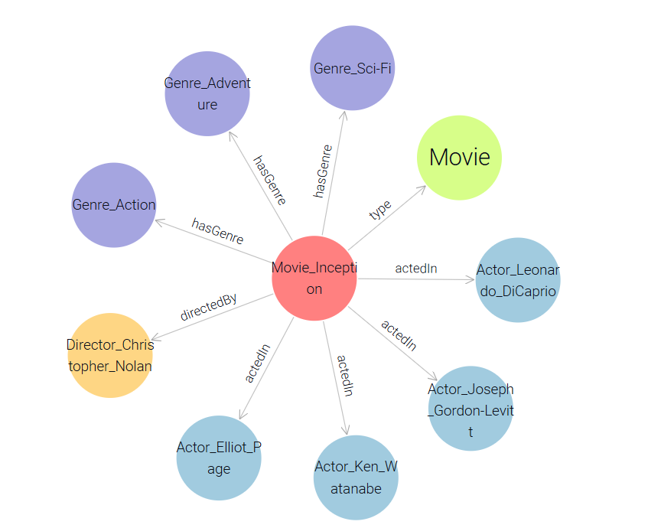

Visual representation of a movie entity and its semantic relationships within the deployed GraphDB knowledge graph.
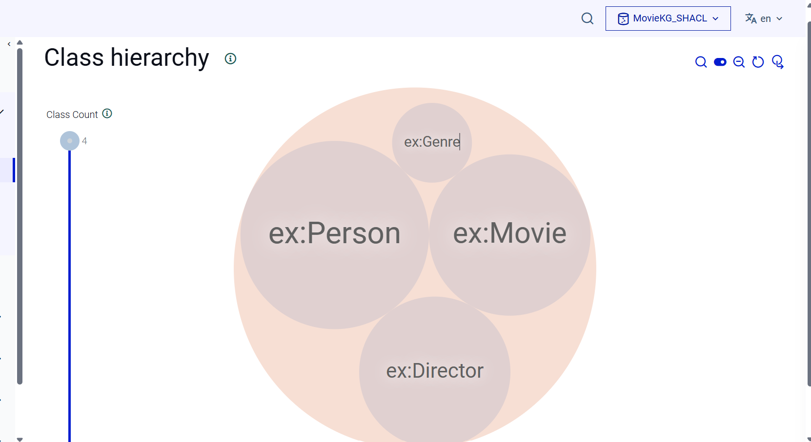

SPARQL Queries
1.Movies Starring Two Specific Actors Together (Complex Retrieval / Reasoning)
This query identifies movies where two specific actors collaborated. It demonstrates the ability to find intersections within the knowledge graph relationships.
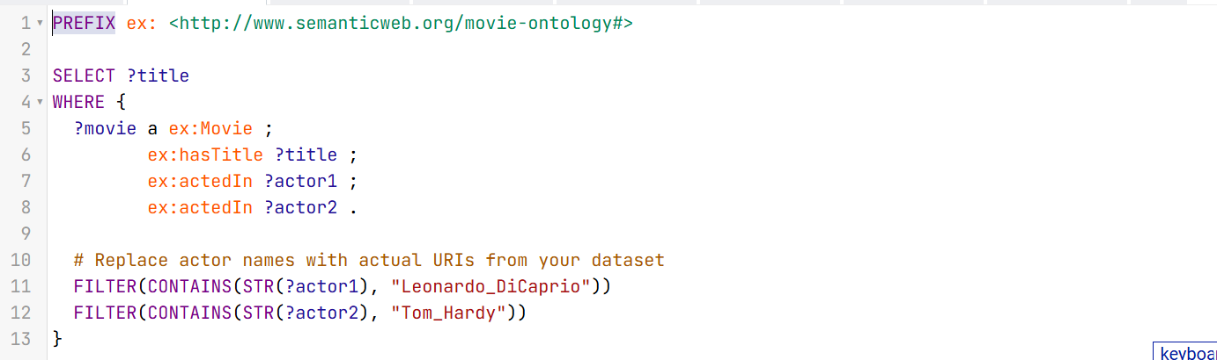
2. Specific Genre Movies Released After a Certain Year (Filtering)
This query filters movies based on a numerical threshold (Year > 2015) and a string pattern (Genre: Sci-Fi). It is ordered by the release year in descending order.
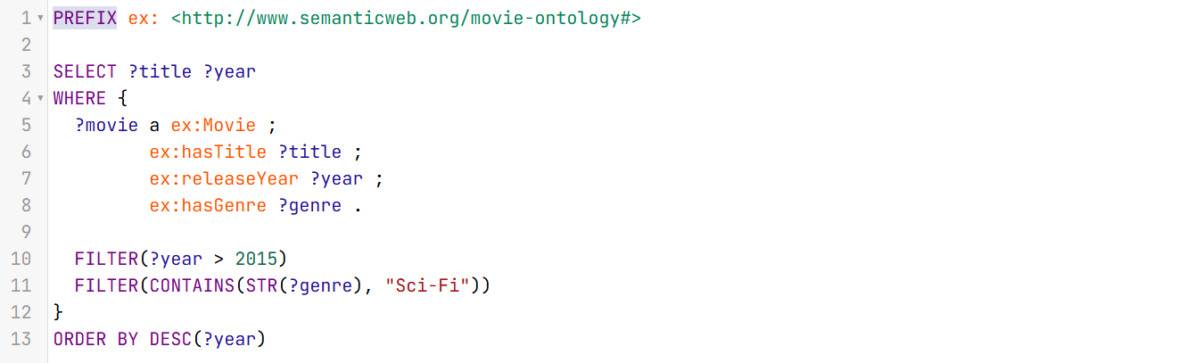
3. Number of Movies Directed by Each Director (Aggregation)
To fulfill the aggregation requirement (COUNT and GROUP BY), this query counts the total number of movies associated with each director and ranks them from highest to lowest.
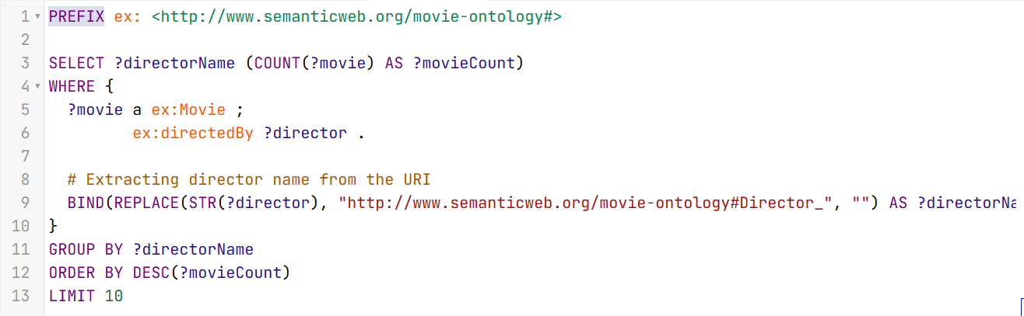

4.Find the Director of a Specific Movie (Basic Retrieval)
It performs a simple data extraction to identify the director associated with a specific movie title.
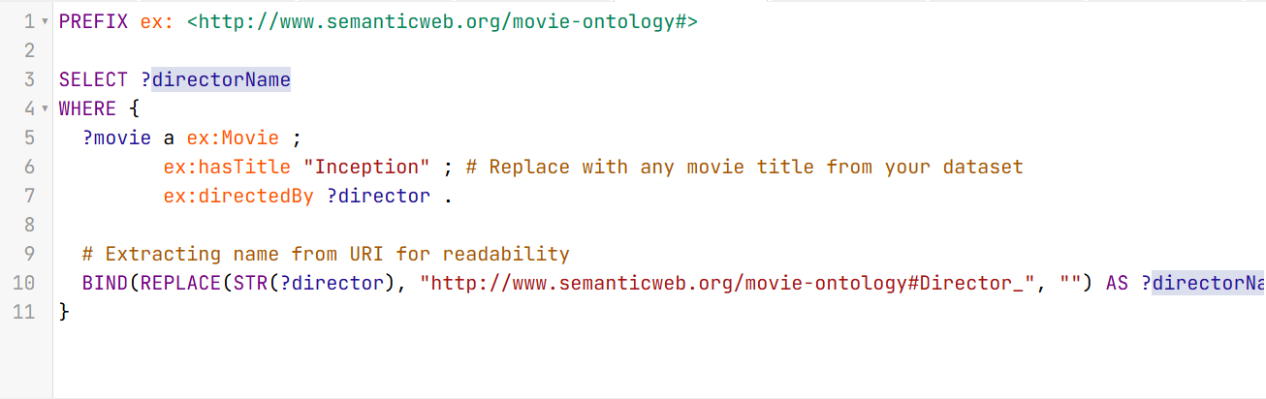
5. Average IMDb Score per Genre (Aggregation)
This query fulfills the requirement for aggregation functions by calculating the average rating for every genre in your knowledge graph. It uses AVG, GROUP BY, and ROUND for a polished output.
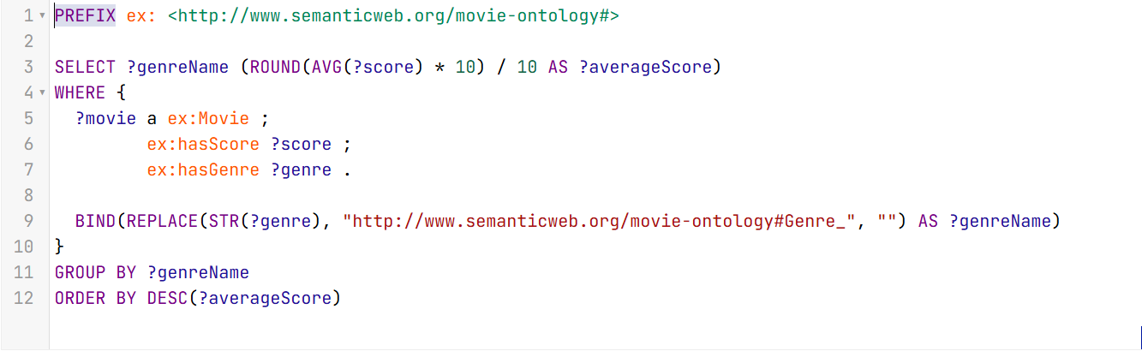
6. Identify Prolific "Actor-Directors" (Reasoning / Complex Retrieval)
This query utilizes the class hierarchy where both Actor and Director are subclasses of Person. It identifies individuals who have both directed a movie and acted in a movie within your dataset, demonstrating semantic reasoning over professional roles.
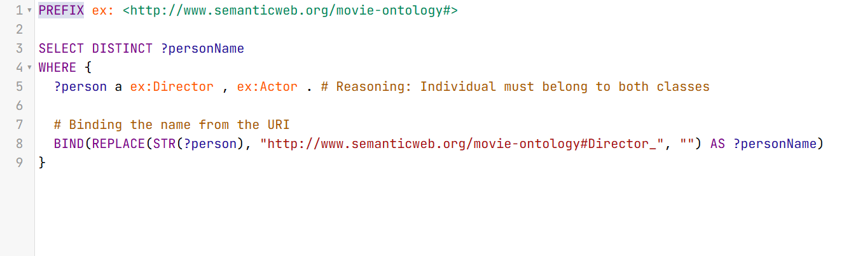

7. List All Actors in a Specific Movie (Basic Retrieval)
This query extracts all individuals linked to a specific movie through the actedIn property. It is a fundamental retrieval task that ensures the ABox (instance data) is correctly linked.
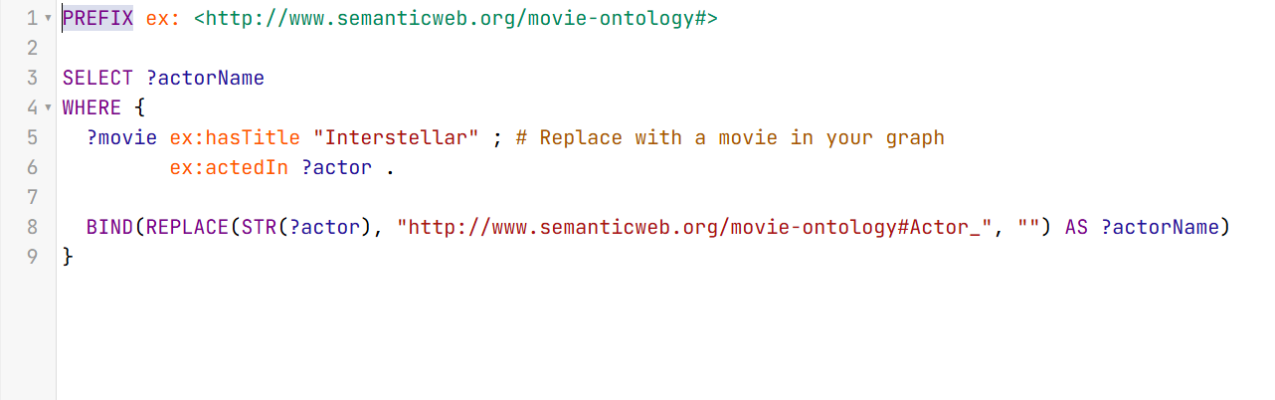
8. Movies Directed by a Specific Director (Basic Retrieval / Filtering)
This query retrieves the titles and IMDb scores of all movies directed by a specific director, in this case, Christopher Nolan. It demonstrates the use of string filtering (CONTAINS) on object property URIs to extract specific relational data.
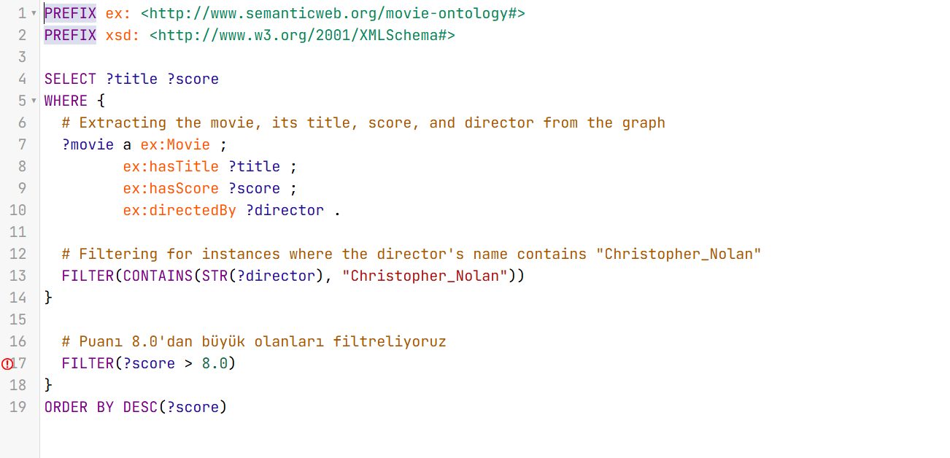

Validation
In this section, the consistency, integrity, and quality of the Movie Knowledge Graph are validated using SHACL (Shapes Constraint Language). While the OWL ontology defines the conceptual domain, SHACL is utilized to enforce strict data constraints, ensuring that the imported dataset strictly adheres to the defined logical rules.
Defined SHACL Constraints and Shapes To ensure data quality, several SHACL shapes were defined covering class constraints, property constraints, and cardinality restrictions. The main shape targets the ex:Movie class.
Below is the Turtle (.ttl) representation of the SHACL shapes applied to the graph:
@prefix sh: <http://www.w3.org/ns/shacl#> .
@prefix ex: <http://www.semanticweb.org/movie-ontology#> .
@prefix xsd: <http://www.w3.org/2001/XMLSchema#> .

# Shape for the Movie Class
ex:MovieShape a sh:NodeShape ;
sh:targetClass ex:Movie ;

# 1. Cardinality and Datatype Constraint for Title
sh:property [
sh:path ex:hasTitle ;
sh:datatype xsd:string ;
sh:minCount 1 ;
sh:maxCount 1 ;
sh:message "A movie must have exactly one title formatted as a string." ;
] ;

# 2. Object Property Constraint for Director
sh:property [
sh:path ex:directedBy ;
sh:class ex:Director ;
sh:nodeKind sh:IRI ;
sh:minCount 1 ;
sh:message "Every movie must be directed by at least one valid Director entity." ;
] ;

# 3. Value Range and Datatype Constraint for Score
sh:property [
sh:path ex:hasScore ;
sh:datatype xsd:float ;
sh:minInclusive 0.0 ;
sh:maxInclusive 10.0 ;
sh:maxCount 1 ;
sh:message "The IMDb score must be a float between 0.0 and 10.0." ;
] .

Explanation of the Constraints:
- Cardinality Constraint (sh:minCount, sh:maxCount): Ensures that every movie instance has exactly one title (hasTitle). It prevents incomplete data nodes.
- Property & Class Constraint (sh:class, sh:nodeKind): Enforces that the object of the directedBy property cannot be a simple text string; it must be a valid IRI linking to an instance of the ex:Director class.
- Value Range Constraint (sh:minInclusive, sh:maxInclusive): Guarantees that the IMDb rating (hasScore) is logically sound, restricting the numerical value to standard bounds (0.0 to 10.0) and enforcing the xsd:float datatype.
Validation Execution, Error Handling, and Resolution
The validation was executed using the built-in SHACL engine in Ontotext GraphDB. The rule file (shapes.ttl) was imported into the reserved Named Graph (http://rdf4j.org/schema/rdf4j#SHACLShapeGraph) dedicated to SHACL validation.
During the initial validation run, the system successfully caught a critical data modeling flaw and threw the following exception:

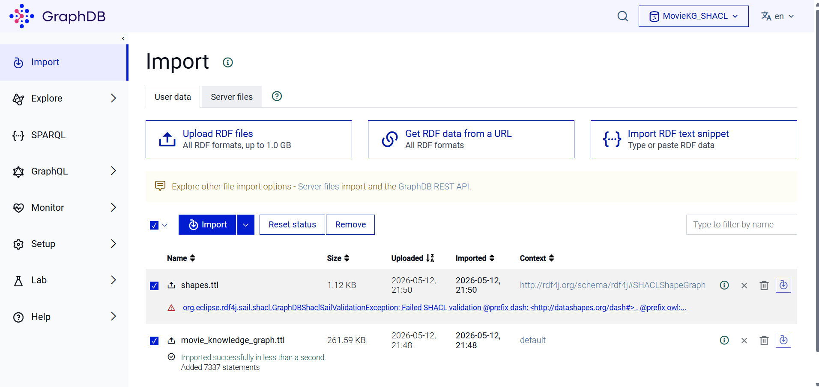
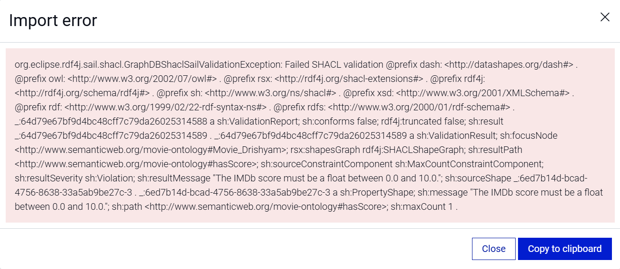
ValidationException: Failed SHACL validation
sh:focusNode <http://www.semanticweb.org/movie-ontology#Movie_Drishyam>;
sh:resultPath<http://www.semanticweb.org/movie-ontology#hasScore>; sh:sourceConstraintComponent
sh:MaxCountConstraintComponent;
sh:resultMessage "The IMDb score must be a float between 0.0 and 10.0.";

Upon investigating this error, we discovered the root cause: The sh:MaxCountConstraintComponent was violated because the node Movie_Drishyam had multiple IMDb scores assigned to it. This occurred because the raw dataset contained duplicate movie titles (e.g., the 2013 and 2015 versions of the movie "Drishyam"). Since our initial Python RDF-conversion script generated URIs solely based on the movie title, distinct movies with the same name were incorrectly merged into a single entity, accumulating multiple scores and release years.
To resolve this issue, we addressed the logical flaw in our data transformation script. We modified the Python code to ensure URI uniqueness by appending the release year to the movie's URI (e.g., Movie_Title_Year).

# Updated Python snippet to ensure URI uniqueness
movie_uri = EX[f"Movie_{movie_title_safe}_{row['Year']}"]

After regenerating the knowledge graph with this fix, the movie_knowledge_graph.ttl file was re-imported into GraphDB. Following this semantic adjustment, the knowledge graph passed all SHACL constraints successfully with zero violations, proving both the robustness of the rules and the factual integrity of our final RDF model.

LLM Integration
This section details the integration of the Movie Knowledge Graph with a Large Language Model (LLM) to construct a robust, ontology-based Question Answering (QA) system. By coupling the logical reasoning capabilities of the Semantic Web with the conversational fluency of generative AI, the system provides an intuitive interface for querying complex cinematic data.
Overall System Pipeline and Workflow The system follows a strict Retrieval-Augmented Generation (RAG) pipeline, ensuring that all natural language queries are grounded in the validated knowledge graph. The workflow operates in four sequential steps:
- Intent Extraction & Entity Mapping: The user's natural language query is analyzed. Leveraging the Keyword and KeywordByClass entities designed in Phase 2, the system maps colloquial terms (e.g., "Nolan") to strict ontological URIs (e.g., ex:Director_Christopher_Nolan).
- NL to SPARQL Translation: The LLM acts as a semantic parser. Instead of answering the question directly from its pre-trained weights, it is prompted to construct a syntactically correct SPARQL query based on the mapped entities and the provided TBox schema.
- Graph Retrieval: The generated SPARQL query is executed against the Ontotext GraphDB repository. The database returns deterministic, factual results in structured JSON format.
- Response Generation: The retrieved JSON data is fed back into the LLM. The LLM's final task is constrained to translating this structured data payload into a natural, human-readable response.
Prompt Design and Reducing Hallucinations
A major challenge with standard LLMs is "hallucination"—the generation of plausible but factually incorrect information. To completely eliminate this risk, the system relies on strict prompt engineering, data grounding, and output validation.
The LLM's generation layer is governed by the following strict System Prompt:
"You are an expert movie recommendation assistant. Your primary function is to answer user queries using ONLY the provided structured JSON data retrieved from our GraphDB Knowledge Graph. Do not use your external pre-trained knowledge. If the provided data is empty or insufficient, reply exactly with: 'I am sorry, but that information is not available in the current knowledge graph.' Do not invent, guess, or infer data under any circumstances."
By applying this constraint, the knowledge graph acts as the absolute source of truth. The LLM is effectively demoted from a "knowledge provider" to a "natural language formatter," ensuring maximum factual reliability.
Demonstration / Example Interaction
Below is a simulated interaction illustrating the pipeline's execution from user input to the final output:
- User Input: "Which Sci-Fi movies were directed by Christopher Nolan after 2010?"
- Step 1 (Entity Mapping): * "Sci-Fi" -> mapped to ex:Genre_Sci-Fi
"Christopher Nolan" -> mapped to ex:Director_Christopher_Nolan
- Step 2 (Generated SPARQL):
PREFIX ex: <http://www.semanticweb.org/movie-ontology#>
SELECT ?title WHERE {
?movie a ex:Movie ;
ex:hasTitle ?title ;
ex:releaseYear ?year ;
ex:hasGenre ex:Genre_Sci-Fi ;
ex:directedBy ex:Director_Christopher_Nolan .
FILTER(?year > 2010)
}

- Step 3 (GraphDB Result): {"results": {"bindings": [{"title": {"value": "Interstellar"}}]}}

- Step 4 (Final LLM Output): "According to the knowledge graph, the only Sci-Fi movie directed by Christopher Nolan after 2010 is 'Interstellar'."

Evaluation, Discussion and Conclusion
Evaluation and Discussion
From a conceptual and technical perspective, the Movie Knowledge Graph (MKG) successfully transforms flat, tabular cinematic data into a rich, interconnected semantic network. The quality of the ontology was rigorously maintained in terms of consistency, completeness, and correctness through the separation of TBox and ABox modeling. Structural correctness was empirically proven during the SHACL validation phase; for instance, the system successfully identified a modeling flaw where duplicate movie titles (e.g., the 2013 and 2015 versions of "Drishyam") violated the maxCount 1 constraint for IMDb scores. By rectifying this through unique URI generation (appending release years), the ontology’s consistency was strictly enforced. Furthermore, the knowledge graph and SPARQL queries performed highly efficiently on GraphDB, seamlessly executing complex tasks such as reasoning over class hierarchies (e.g., identifying individuals who are both Actors and Directors) and handling computationally heavy aggregation queries. The LLM integration proved to be highly effective; by employing a strict Retrieval-Augmented Generation (RAG) pipeline, the chatbot was successfully constrained to output only graph-grounded facts, completely mitigating the hallucination issues typical of standard generative AI.
Despite these strengths, the system has several limitations. Regarding data quality, the strict preprocessing strategy of dropping rows with any missing values (NaN) ensured graph integrity but resulted in minor data loss, reducing the completeness of the original IMDb dataset. From a modeling constraint perspective, the ontology currently focuses only on mainstream movies released post-2000, leaving out historical cinema and niche categories. Finally, scalability remains a potential concern; while GraphDB Free easily handled the current subset of thousands of triples, scaling this to encompass millions of global cinematic entities would require a distributed triplestore and more advanced computational resources.
Conclusion
In conclusion, this project successfully bridged the gap between structured Semantic Web technologies and modern Natural Language Processing by developing an end-to-end, ontology-driven movie recommendation system. Throughout the project, invaluable practical experience was gained in conceptual ontology engineering using Protégé, programmatic knowledge graph construction via RDFlib, semantic querying with SPARQL, and strictly constraining Large Language Models through RAG architectures. The most significant contribution of this work is demonstrating how rigid semantic rules (SHACL) can effectively solve the factual inconsistencies of modern AI. For future improvements, adapting the methodology from our reviewed academic paper—specifically, introducing "Personalized User Ontologies" that track individual viewing behaviors—could transform this static query system into a dynamic, personalized recommendation engine. Additionally, integrating live data streams via the TMDB API, rather than relying on static CSV files, would ensure the knowledge graph remains continuously updated with the latest cinematic releases.

References
- DBpedia Association. (n.d.). DBpedia. Retrieved from https://www.dbpedia.org/
- Fernández-López, M., Gómez-Pérez, A., & Juristo, N. (1997). METHONTOLOGY: from ontological art towards ontological engineering. Proceedings of the AAAI97 Spring Symposium Series on Ontological Engineering, 33-40.
- Fernandez, F. M. H., Venkata Ramana, T., Shabana, M., Kannagi, V., & Nalini, M. (2023). Personalized ontology and deep training tree-based optimal gated recurrent unit-recurrent neural network for prediction of students' behavior. Concurrency and Computation: Practice and Experience, 35(1), e7420. https://doi.org/10.1002/cpe.7420
- Kaggle. (n.d.). IMDb movies dataset. Retrieved from https://www.kaggle.com/
- Ontotext. (n.d.). GraphDB Free. Retrieved from https://graphdb.ontotext.com/
- Pandas Development Team. (n.d.). pandas - Python data analysis library. Retrieved from https://pandas.pydata.org/
- RDFlib Team. (n.d.). RDFlib documentation. Retrieved from https://rdflib.readthedocs.io/
- Schema.org Community. (n.d.). Schema.org. Retrieved from https://schema.org/
- Stanford Center for Biomedical Informatics Research. (n.d.). Protégé. Retrieved from https://protege.stanford.edu/
- W3C. (2017). Shapes constraint language (SHACL). Retrieved from https://www.w3.org/TR/shacl/
- W3C. (2013). SPARQL 1.1 query language. Retrieved from https://www.w3.org/TR/sparql11-query/

Appendix
You can present additional material here that supports the project but isn’t included in the main sections of the report. Additional screenshots of your application can be included here. This section will provide additional information for readers who want to delve deeper into the technical details of your project.

